Chapter 2, Solution 47

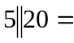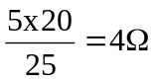

6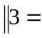 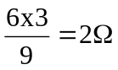

4 Ω
10 Ω
8 Ω
2 Ω
a
b

R_{ab} = 10 + 4 + 2 + 8 = 24 Ω

